**Online Quiz Portal Using REST APIs**

**Code:**

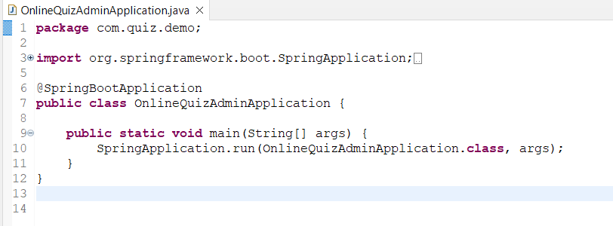

**Admin table:**

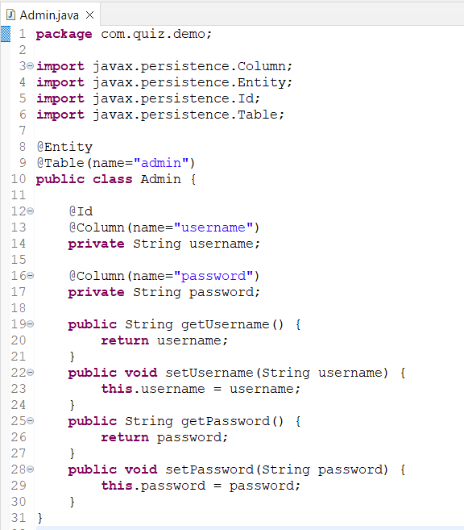

**Admin Repository:**

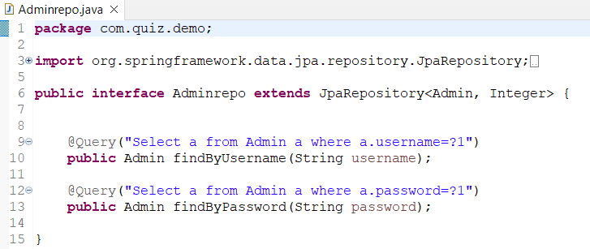

**Quiz Table:**

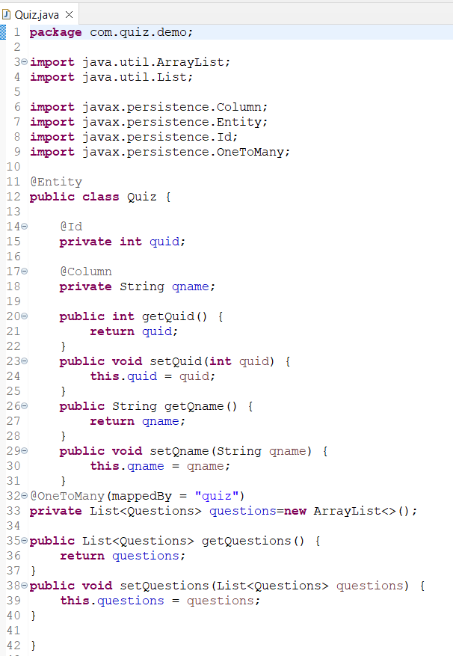

**Quiz Repository:**

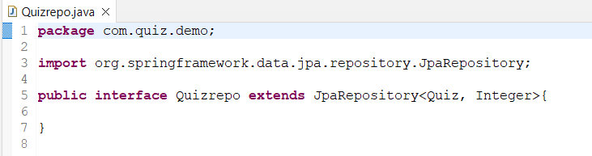

**Questions table:**

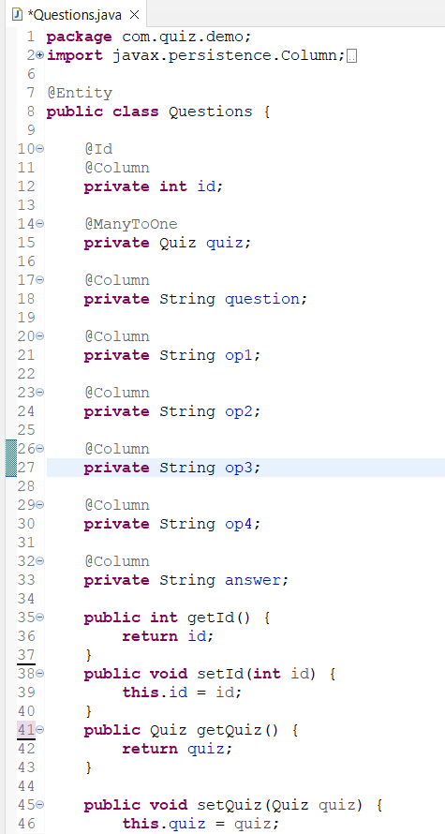

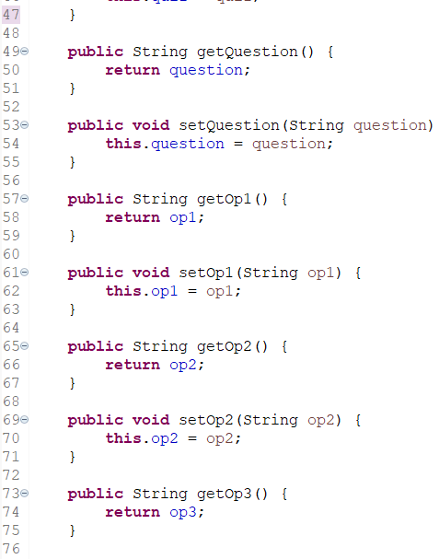

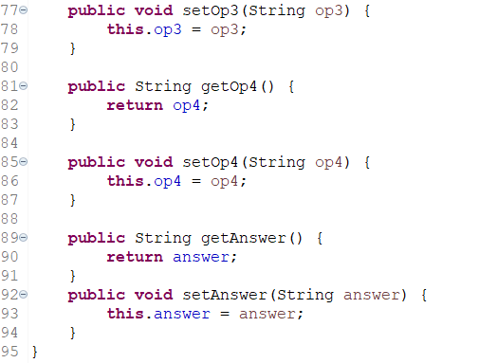

**Questions Repository:**

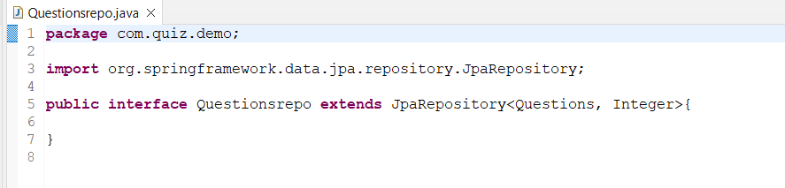

**Marks table:**

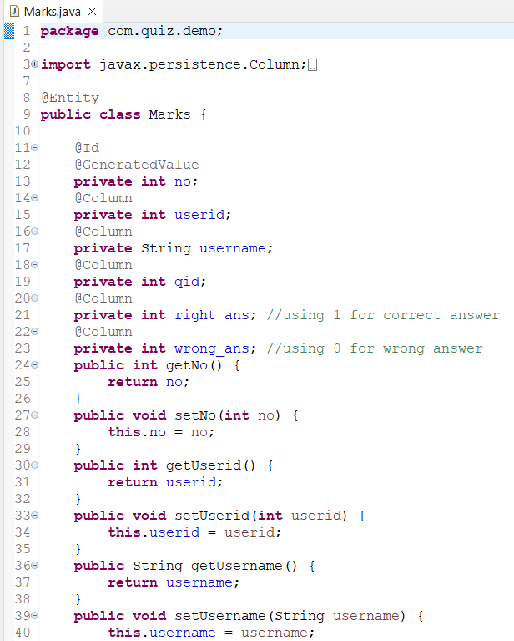

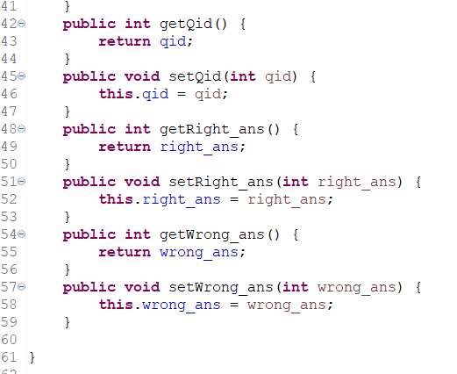

**Marks Repository:**

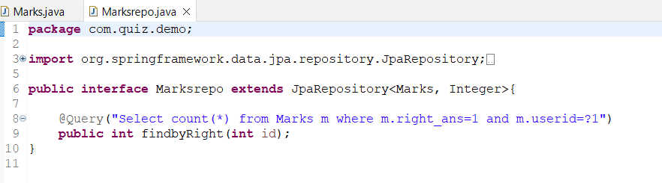

**Quiz Rankings table:**

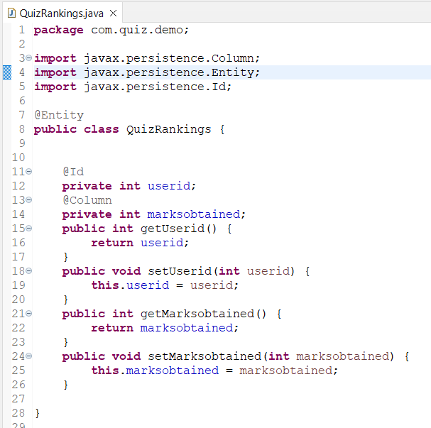

**Repository:**

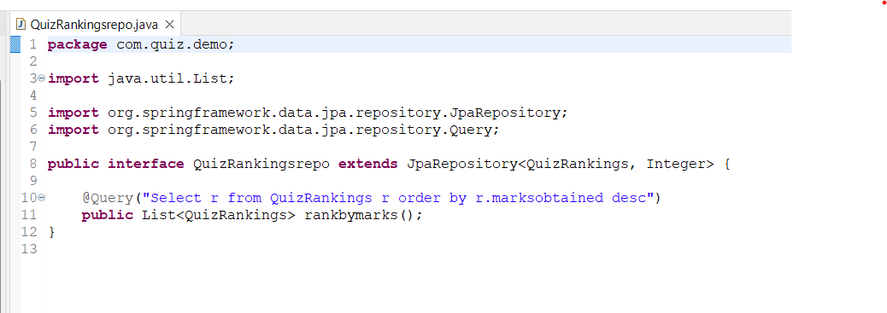

**User Table:**

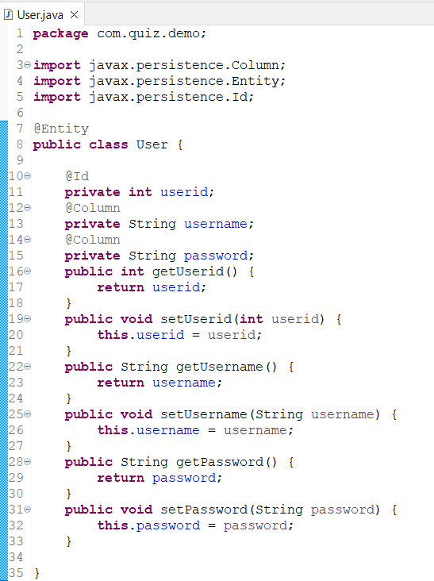

**Repository:**

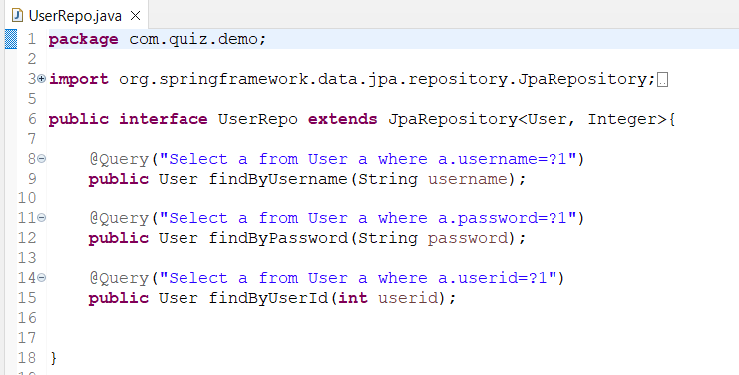

**Admin Controller:**

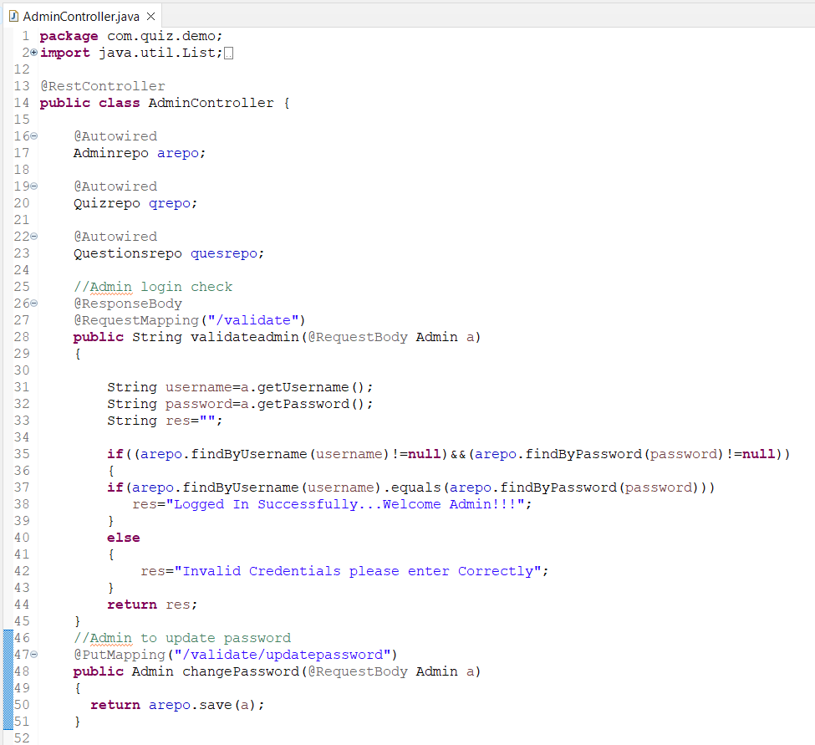

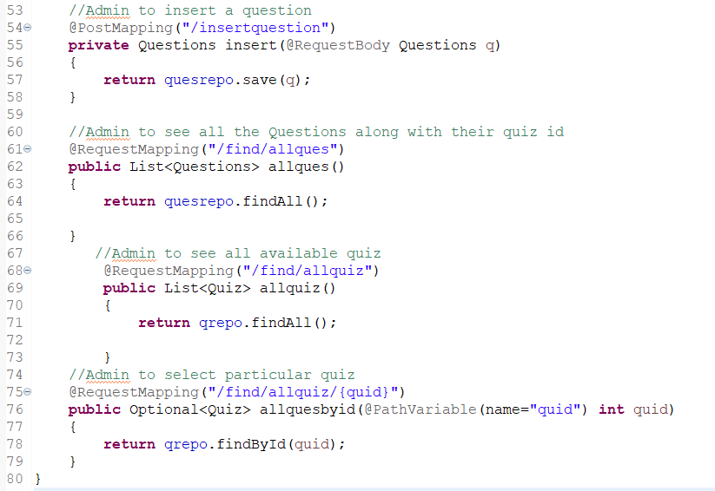

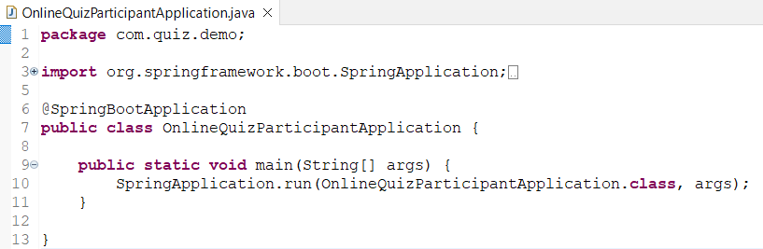

**User Controller:**

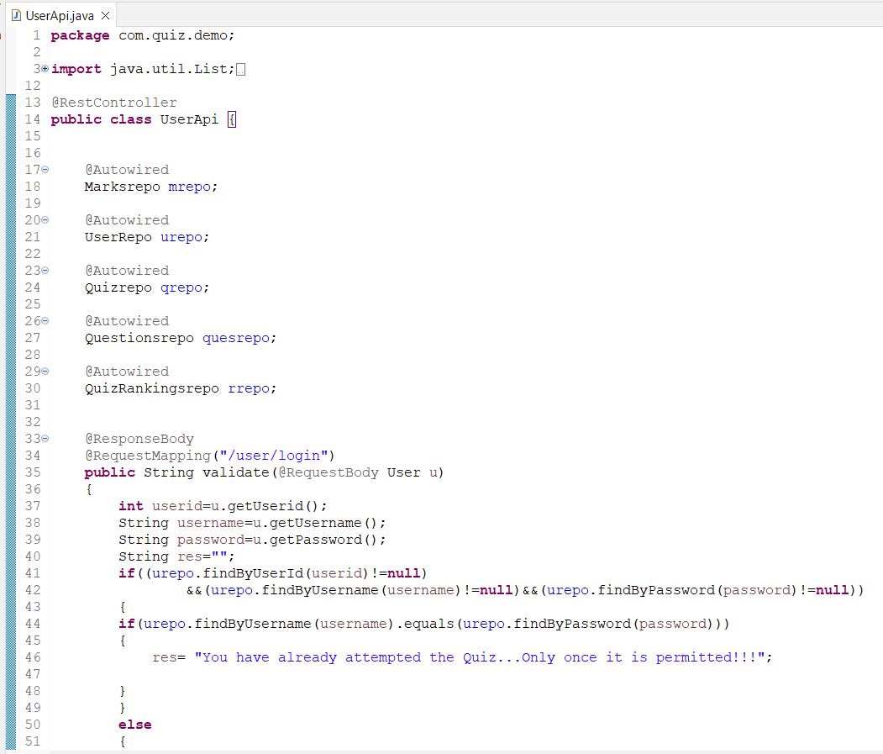

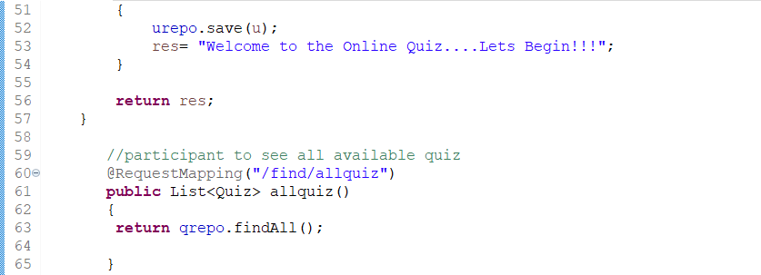

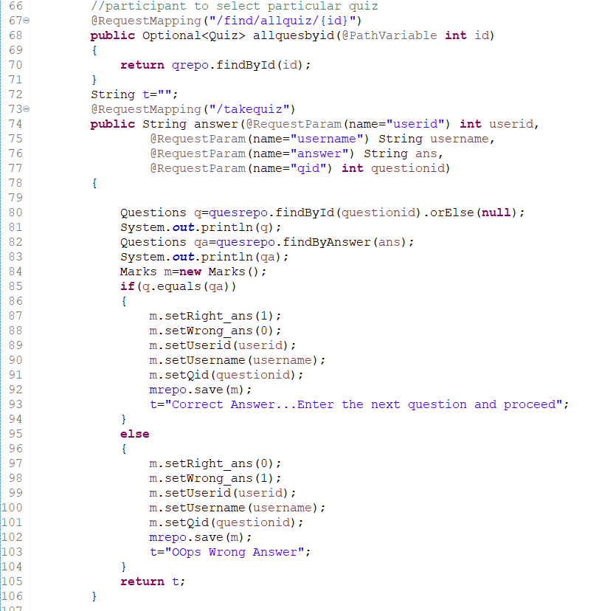

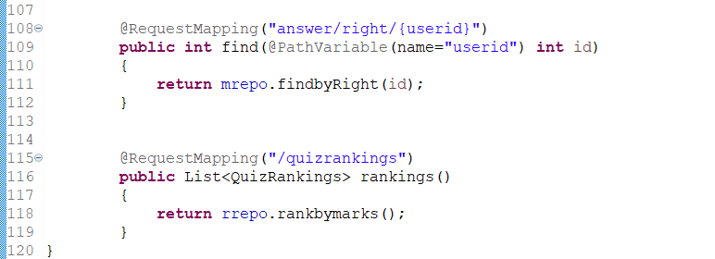

**Outputs and Explanation:**

**Admin side in the Online Quiz portal**

**To validate the login of admin:**

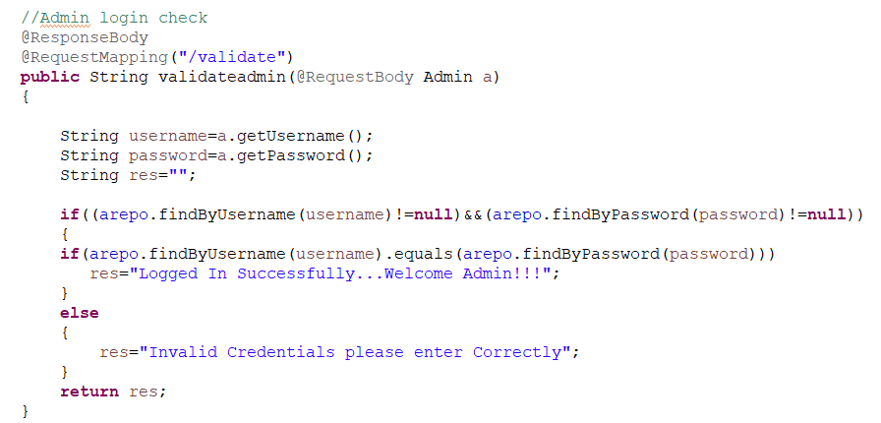

**Need to enter valid admin credentials stored in database**

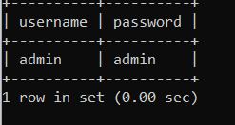

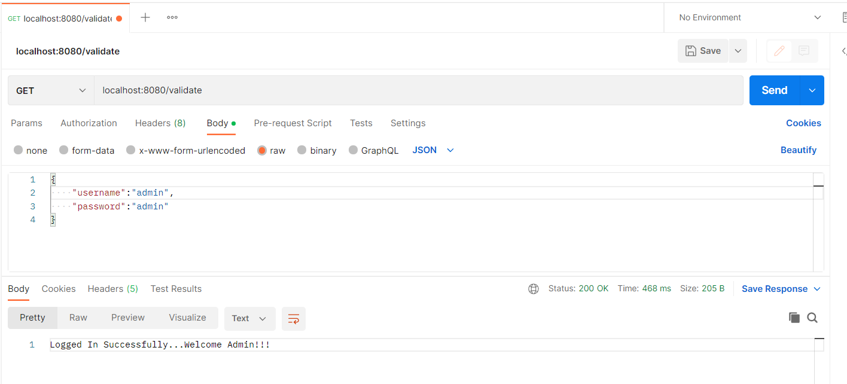

**To update password of Admin and store it in database:**

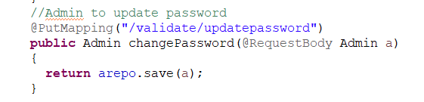

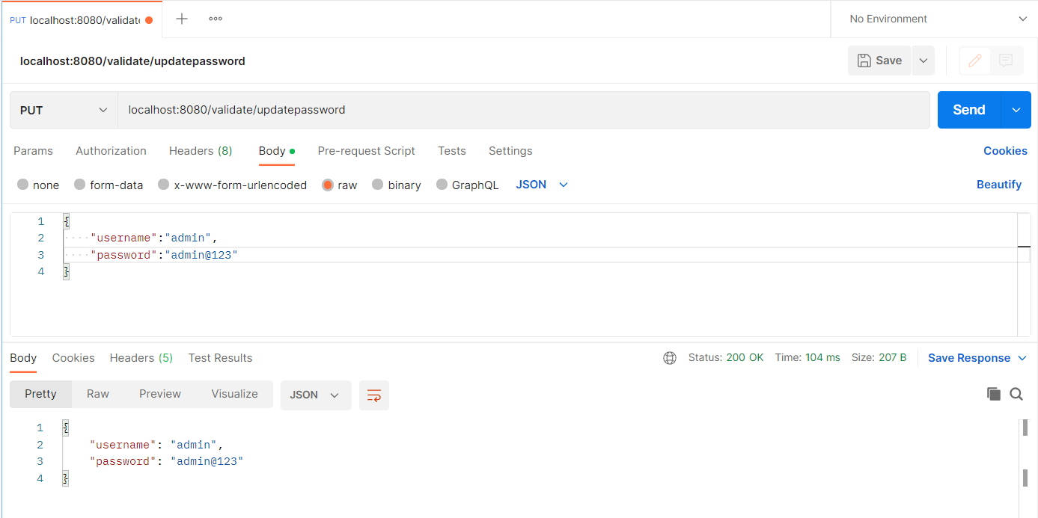

**Password is updated in database**

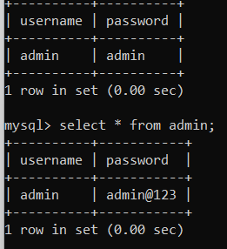

**To insert a quiz to the portal with a particular quiz id:**

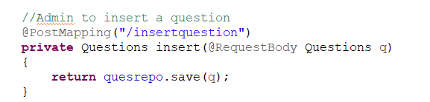

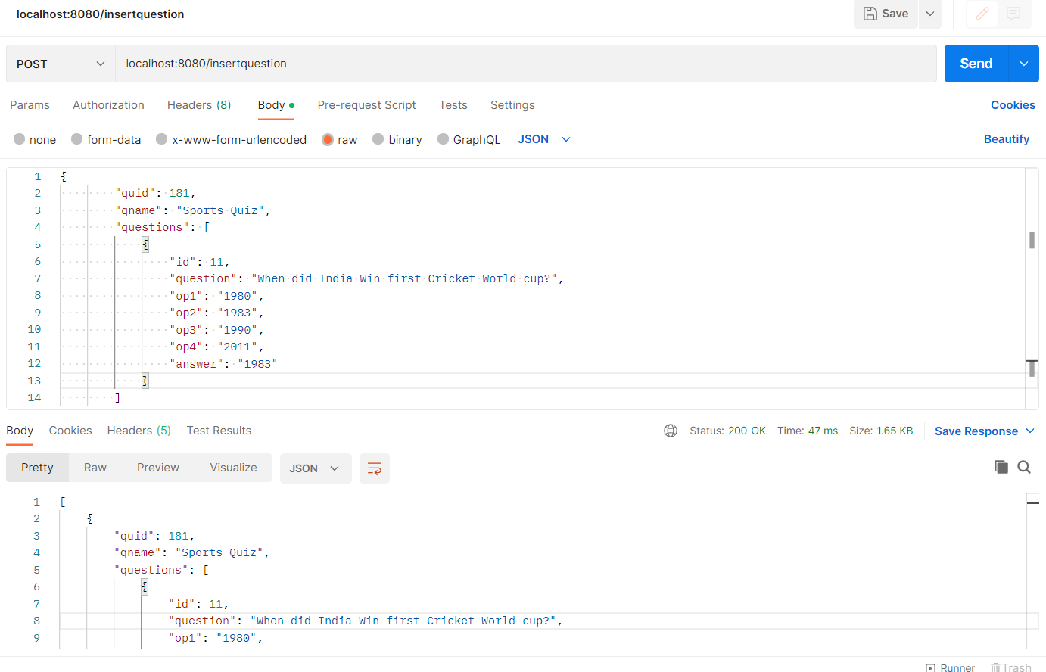

**Question is inserted into the table in the database**



**Admin to see all the questions in the quiz:**

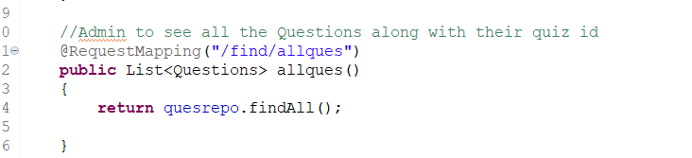

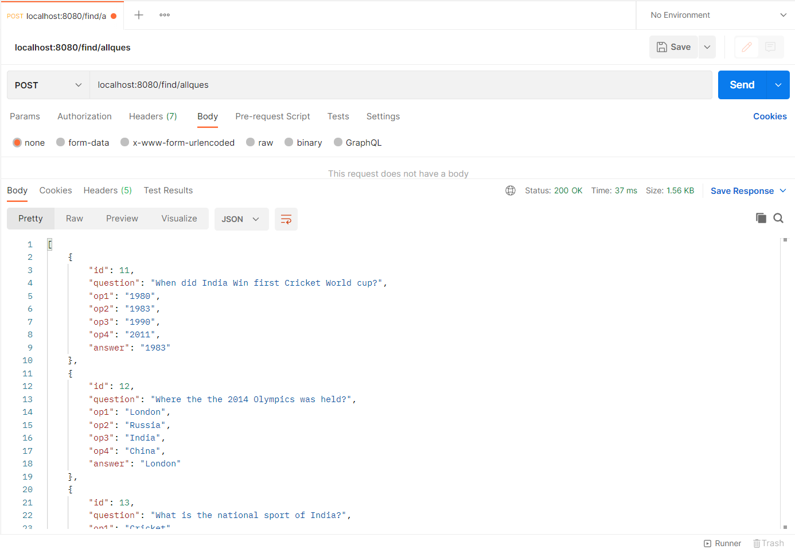

**Admin to select a particular quiz with its quiz id:**

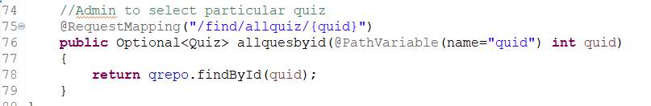

**Quiz id 200 is mentioned all the questions in the quiz with that id are displayed**

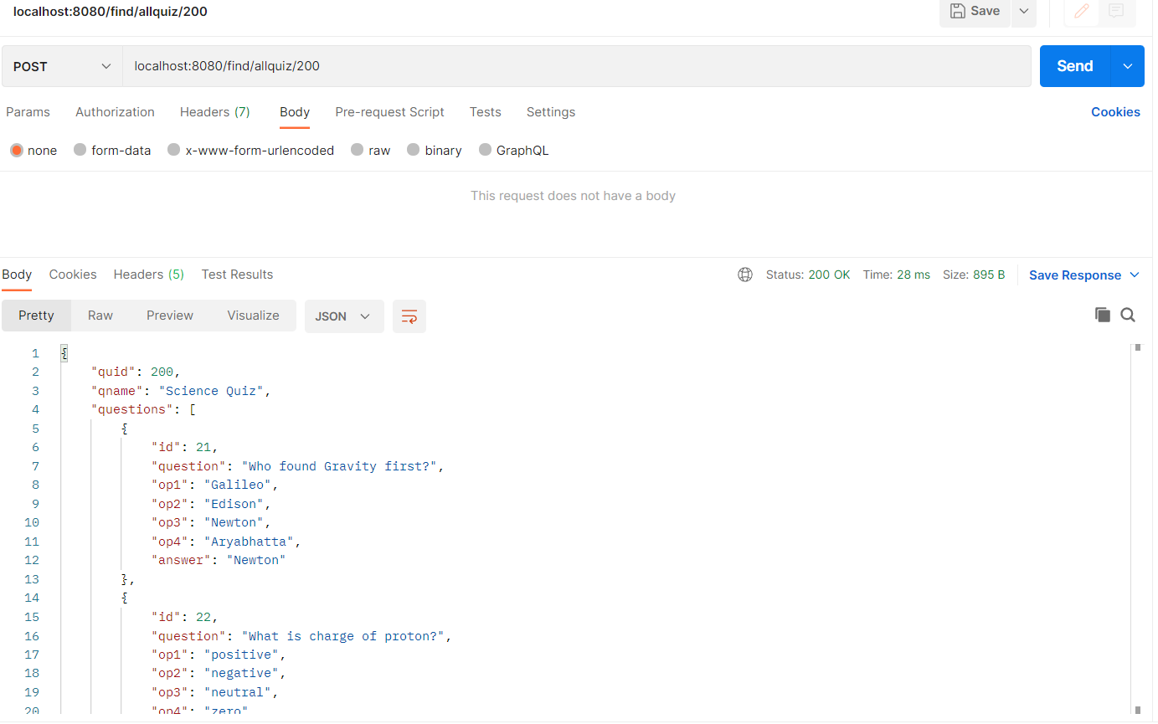

**Participant/User side in the Online Quiz portal**

**Login check of the user:**

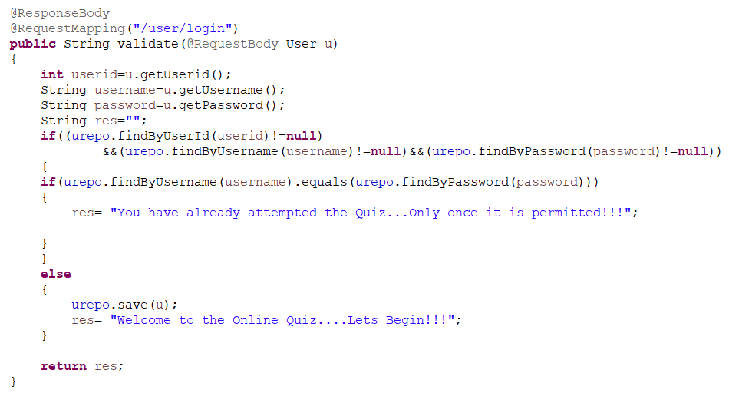

**Since the user here already attempted the quiz**

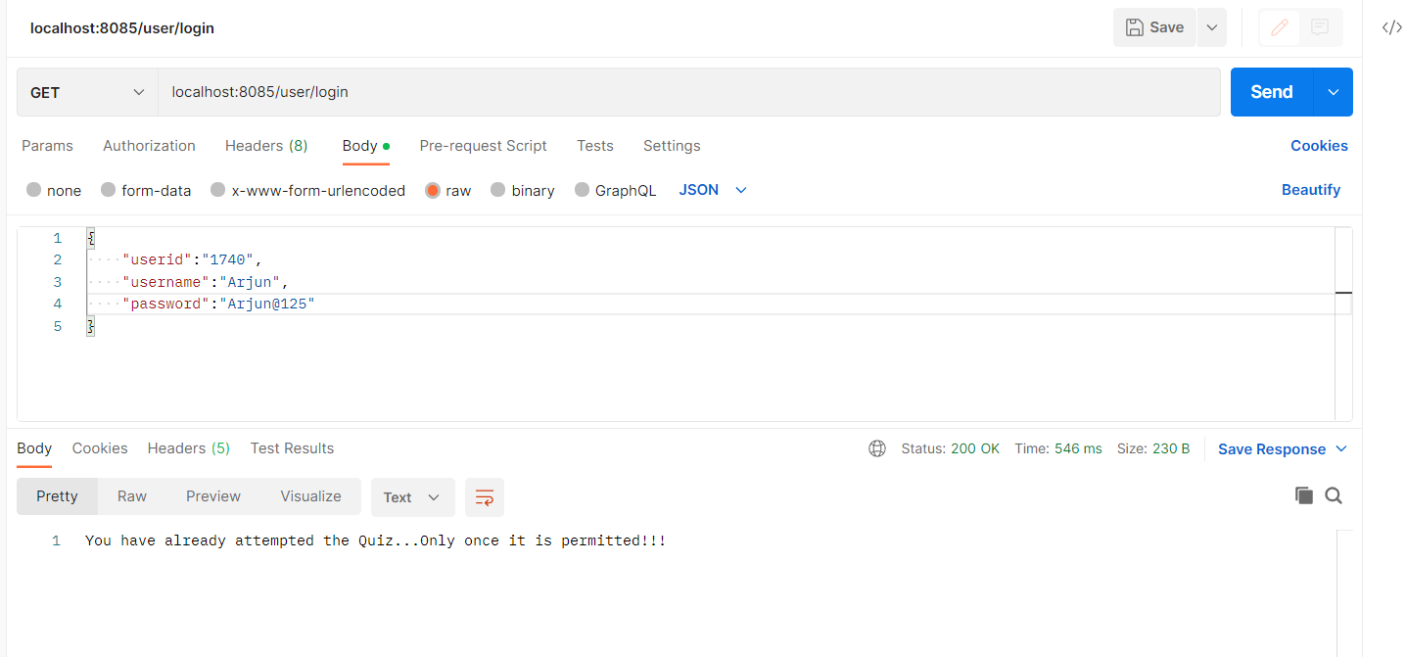

**User to see the available quizzes:**

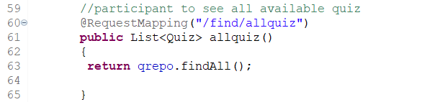

**For user it will only return the quiz id and the quiz name**

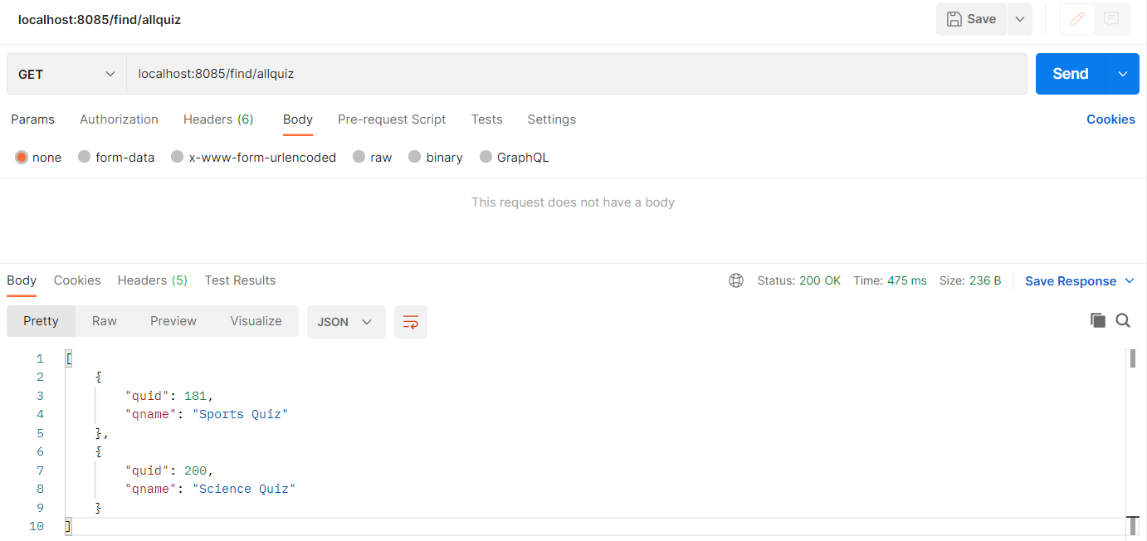

**User to take the quiz:**

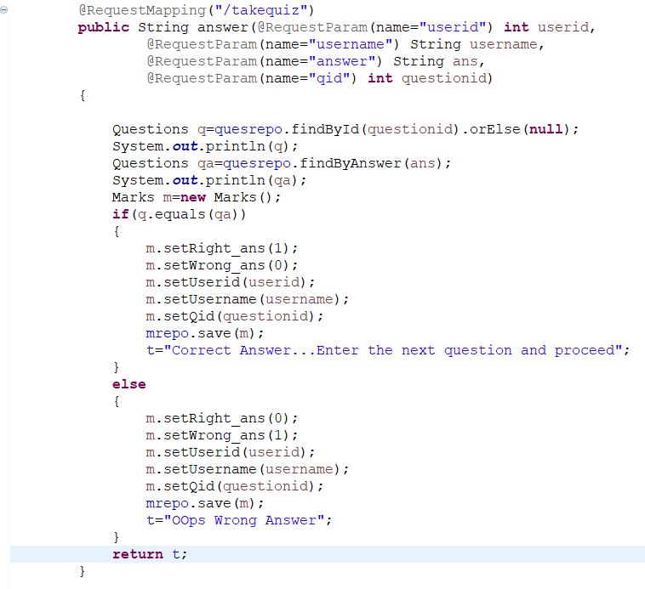

**The question is shown as correct or wrong once you enter answer**

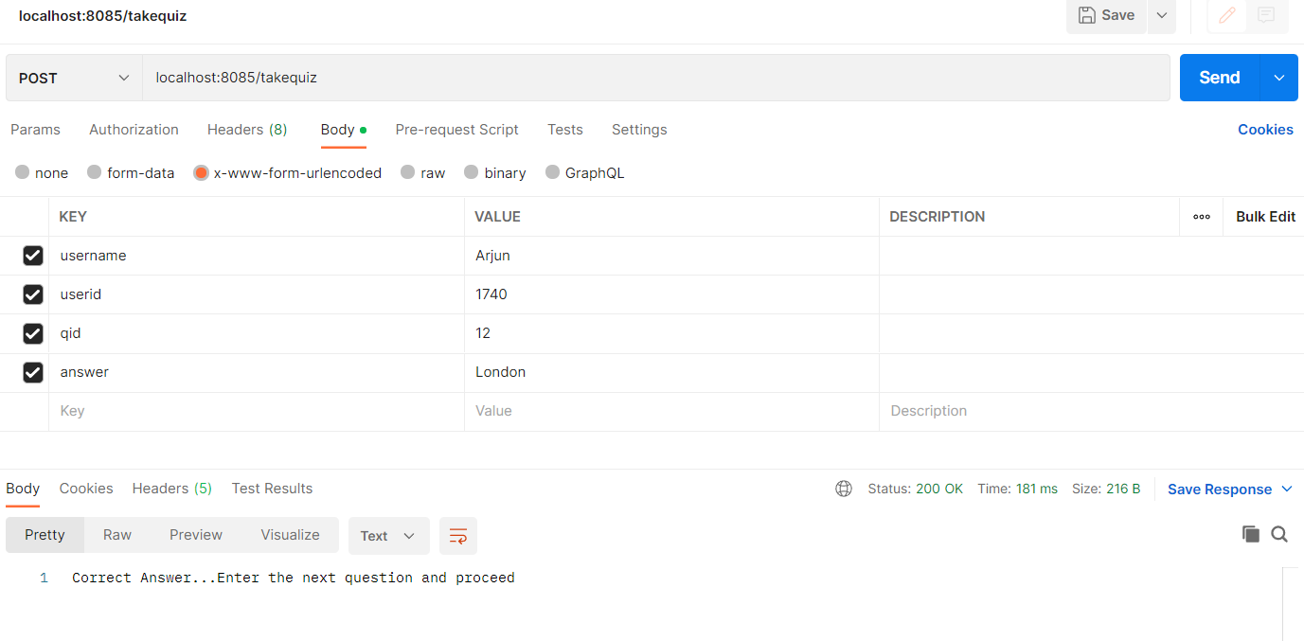

**User can see their Standings:**

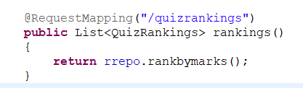

**Here two users have taken the quiz and their standings are**

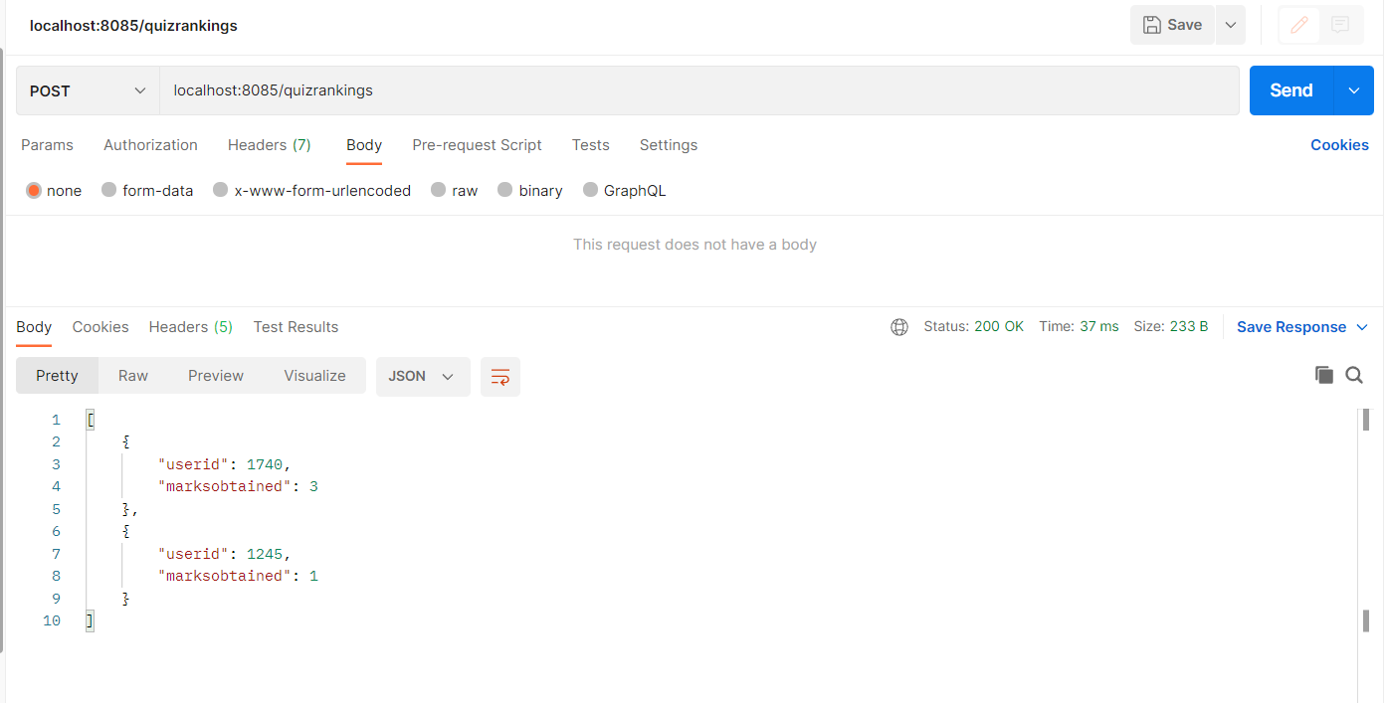

**User can see their result:**

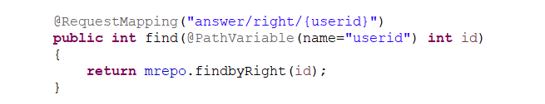

**The user with user id 9682 result is shown below based on number of correctly answered questions.**

